UNIVERSITY INSTITUTE OF COMPUTING

PROJECT REPORT
ON
SIMPLE TOURISM WEBSITE

Program Name: BCA
Subject Name/Code:web designing(25CAH-153)

Submitted by: Submitted to:
Name:Harshpreet Kaur Name: Ms. Preeti
UID: 25BCD10096 Designation:Professor
Section:25BCD2(B)

Project Report: Simple Tourism Website
1. Title
Simple Tourism Website using HTML & CSS
2. Aim of the Project
The aim of this project is to design and develop a simple tourism website using HTML and CSS to display information about popular travel destinations in an attractive and user-friendly manner.
3. Objective
To understand the basic structure of HTML
To apply CSS for styling web pages
To create an attractive tourism website layout
To display travel destinations with images and descriptions
To improve web designing skills
4. Tools and Technologies Used
HTML5
CSS3
Visual Studio Code
Web Browser (Google Chrome)
5. System Requirements
Operating System: Windows 10/11
RAM: Minimum 4GB
Browser: Google Chrome
Code Editor: Visual Studio Code
6. Algorithm / Logic
Start the project
Create the basic structure using HTML
Add header and navigation bar
Insert sections for tourism places
Add images and descriptions
Apply CSS for styling and layout
Design the page to make it attractive
Test the website in browser
End
7. Code Overview
The project is developed using HTML and CSS. HTML is used to create the structure of the website including header, sections, and footer. CSS is used to style the website by applying colors, layout, spacing, and fonts. The website includes a navigation bar and multiple sections to display tourism destinations.
💻 HTML Code
Html
<!DOCTYPE html>
<html>
<head>
<title>Tourism Website</title>
<link rel="stylesheet" href="style.css">
</head>
<body>

<header>
<h1>Explore India</h1>
<nav>
<a href="#">Home</a>
<a href="#">Places</a>
<a href="#">Contact</a>
</nav>
</header>

<section class="hero">
<h2>Discover Beautiful Destinations</h2>
</section>

<section class="places">
<div class="card">
<img src="https://via.placeholder.com/200">
<h3>Manali</h3>
<p>A beautiful hill station in Himachal Pradesh.</p>
</div>

<div class="card">
<img src="https://via.placeholder.com/200">
<h3>Goa</h3>
<p>Famous for beaches and nightlife.</p>
</div>

<div class="card">
<img src="https://via.placeholder.com/200">
<h3>Jaipur</h3>
<p>The Pink City known for forts and culture.</p>
</div>
</section>

<footer>
<p>© 2026 Tourism Website</p>
</footer>

</body>
</html>
🎨 CSS Code
Css

body {
font-family: Arial;
margin: 0;
}

header {
background: #333;
color: white;
padding: 15px;
text-align: center;
}

nav a {
color: white;
margin: 10px;
text-decoration: none;
}

.hero {
background: lightblue;
text-align: center;
padding: 50px;
}

.places {
display: flex;
justify-content: space-around;
padding: 20px;
}

.card {
border: 1px solid #ccc;
padding: 10px;
text-align: center;
width: 200px;
}

.card img {
width: 100%;
}

footer {
background: #333;
color: white;
text-align: center;
padding: 10px;
}
📸 Screenshots / Output
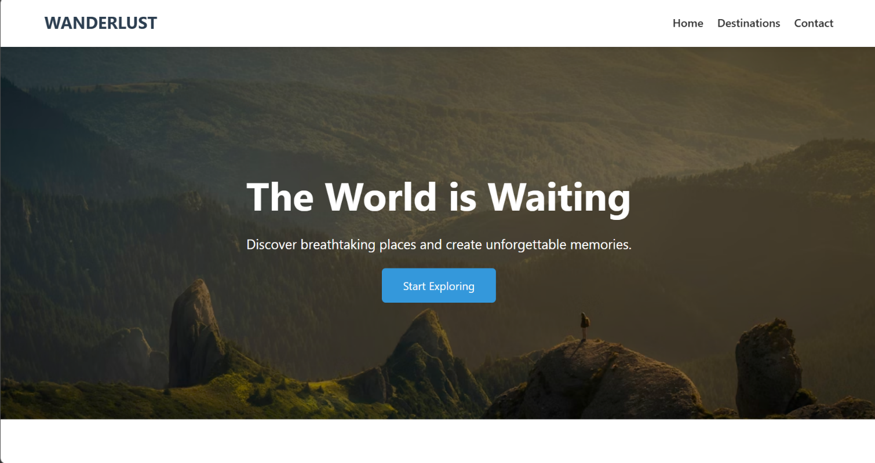
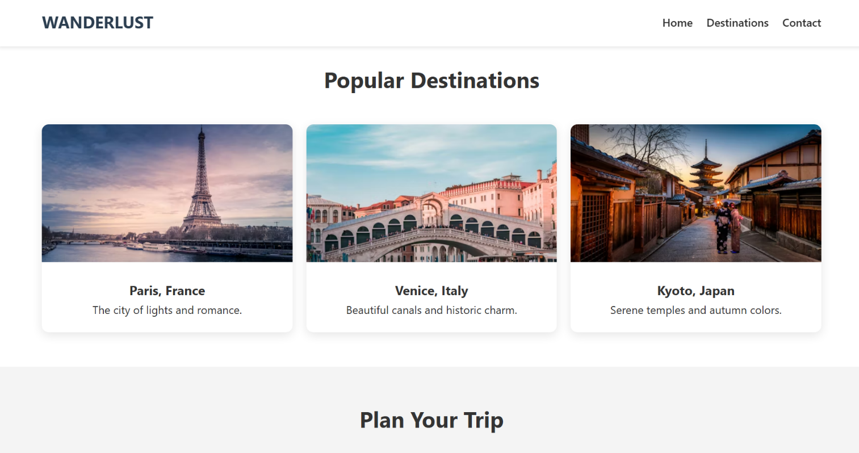
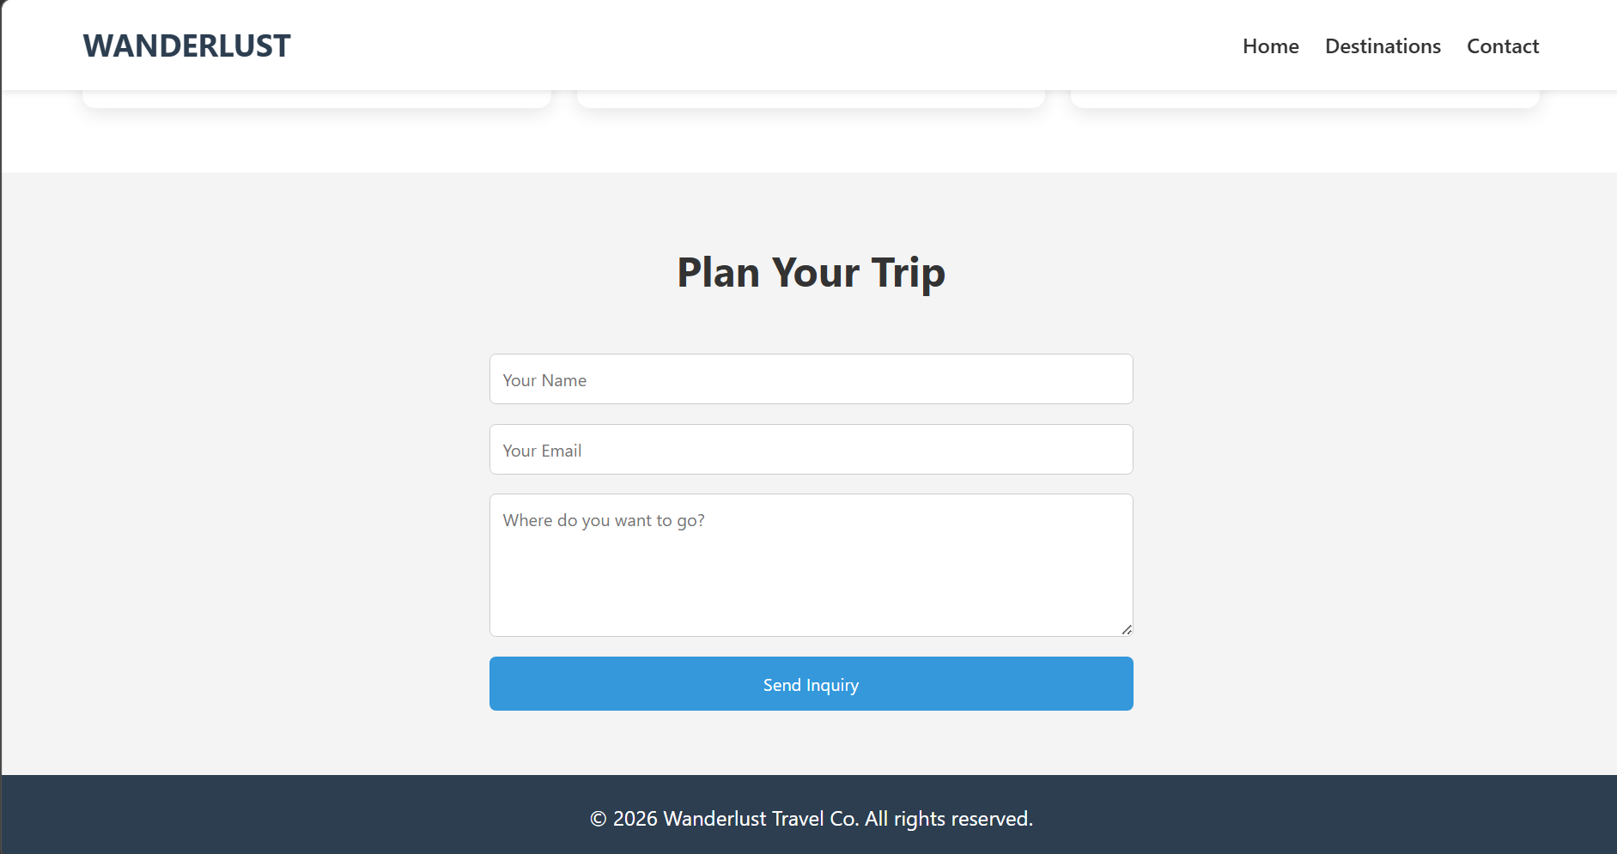

Conclusion
This project helped in understanding the fundamentals of web development using HTML and CSS. It improved the ability to design structured and visually appealing web pages.
10. Learning Outcomes
Learned HTML structure and tags
Applied CSS styling techniques
Understood webpage layout design
Gained practical experience in web development
Improved problem-solving skills
11. References
https://www.w3schools.com⁠�
https://developer.mozilla.org⁠�
Class Notes

